Homework 9

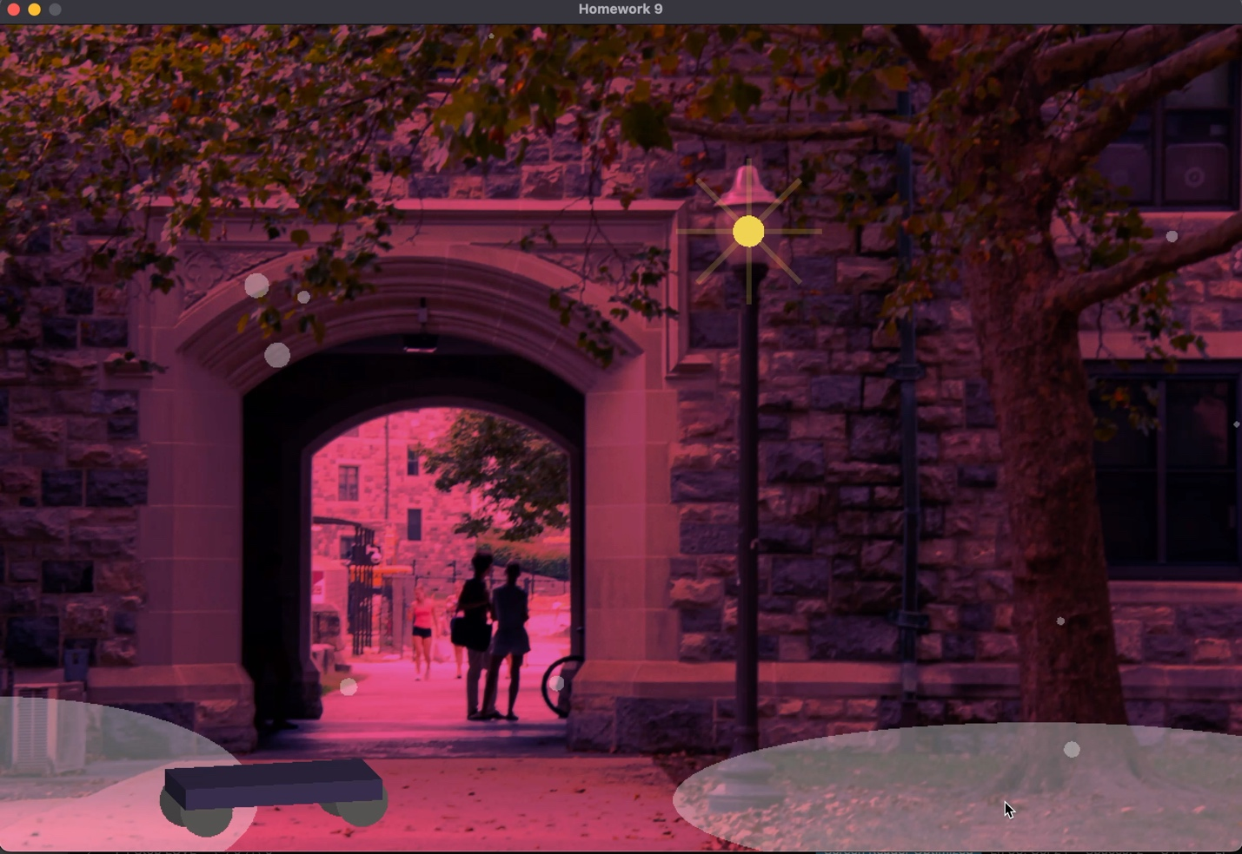
Screen recording:

Main. Lua text:
require("L5")

function setup()
size(1200, 800)

-- Set the program title
windowTitle("Homework 9")
describe('Draws an image of a landscape')
angleMode(DEGREES)
rectMode(CENTER)
rotNum= 0
--set Image variable
--load landscape image
landscapeimage1= loadImage('Assets/image1.jpg')

end

function draw()

-- Fills the background with the color black
background(0)

--add a flourescent pink tint
tint(255,108,199,230)
--load image
image(landscapeimage1)
--remove tint
noTint()
--Add light in the lamp
--make a circle for the light
fill(242,212,83)
noStroke()
ellipse(723.1828,200.4079,30.5971,30.5971)
--make a radial of rectangles

for i= 1,8, 1 do
push()
translate(723.1828,200.407)
rotate (i*45)
fill(242,212,83,50)
noStroke()
rect(40,0,60.8583,5.2501)
pop()
end

--make snow piles
fill(255,255,255,90)
noStroke()
ellipse(0,750,500,200)

fill(255,255,255,90)
noStroke()
ellipse(1000,750,700,150)
--make a scooter
--make the bottom
--make wheels
strokeWeight(10)
fill(68,66,66)
ellipse(180.1527,750.6146,50.9139,50.9139)

strokeWeight(10)
fill(68,66,66)
ellipse(330.1527,740.6146,50.9139,50.9139)

strokeWeight(10)
fill(86,83,82)
ellipse(200.1527,760.6146,50.9139,50.9139)

strokeWeight(10)
fill(86,83,82)
ellipse(350.1527,750.6146,50.9139,50.9139)

--make base board
fill(42,33,56)
noStroke()
quad(160,720,180,740,370,730,350,710)

fill(58,47,79)
noStroke()
quad(180,740,180,760,370,750,370,730)

fill(29,24,40)
noStroke()
quad(160,720,160,740,180,760,180,740)

--make snow
for i = 1, 10 do
frameRate(10)
x = random(width)
y = random(height)
size = random(5, 25)
fill(255,255,255,90)
circle(x, y, size)
end

end

Link to Github:

https://github.com/bhavyamg1234/Creative-Code-Unit-2.git

Reasoning:
I wanted to create scenery that matched the atmosphere. I worked on making the lamppost light shine. I also made snow that fell in a random pattern. As a result of the falling snow, I made two snow patches on the ground. The scooter doesn’t really have a reason behind it, I just thought it was fun. I lowered the opacity of the snow, the snow piles, and the lamp.

